**Part 1: Getting to Know Me**

|  |
| --- |
| Insert photo here |

|  |  |
| --- | --- |
| My Name is |  |
| My Gender/s |  |
| My Pronoun/s |  |
| My Age |  |

|  |  |
| --- | --- |
| People who contributed |  |
| CASoP Practitioner |  |

|  |  |
| --- | --- |
| I am good at |  |
| I like to do |  |
| What is important to me |  |
| My motivations are |  |
| A good day for me is |  |
| A bad day for me is |  |
| Important people in my life |  |

**Communication**

|  |  |
| --- | --- |
| How I Communicate(AAC devices/visual schedules/dialogue type) |  |
| How You can Communicatewith Me |  |
| Communication and Working Together |  |

**My Support Network**

|  |  |
| --- | --- |
| My Informal Supports |  |
| My Paid Supports |  |
| My Community Supports |  |

**Keeping Healthy and Safe**

|  |  |
| --- | --- |
| Internal Stressors (grief/loss/loneliness/motivations) |  |
| External Stressors (environment/workers regulation/pain/communication and language) |  |
| My Physical Health (Medications/sleep/diet/caffeine/exercise) |  |
| My Safety  (risk of abuse/neglect/exploitation) |  |

**My Needs**

|  |  |
| --- | --- |
| You can help me meet my needs by |  |
| Things I need are |  |
| When my needs are unmet, I react by |  |

You can help me to stay in the green zone by ensuring that I can communicate my needs, and have my needs met.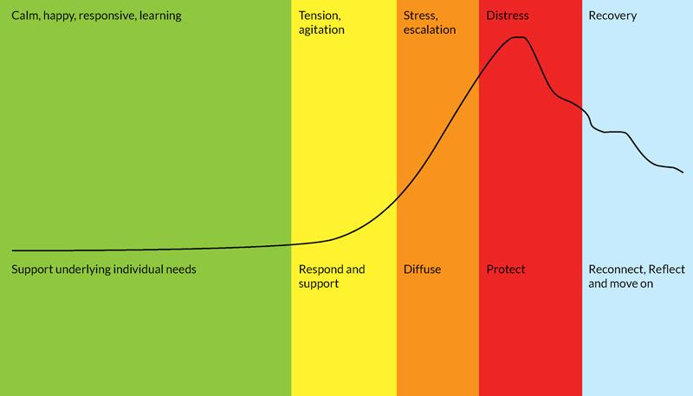

|  |  |  |
| --- | --- | --- |
| **Zone** | **What I am Doing** | **How you can Help Me** |
| **Green Zone** |  |  |
| **Yellow Zone** |  |  |
| **Orange Zone** |  |  |
| **Red Zone** |  |  |
| **Blue Zone** |  |  |

**Supporting My Mental Health**

|  |  |
| --- | --- |
| How you can support stress reduction  (co regulation/ knowing about my stress cycle) |  |
| How you can help me when I am feeling overwhelmed  (co regulation/meditation) |  |
| How you can help me when I am in crisis  (who to call/checklists etc) |  |
| I need you to intervene when |  |
| When you intervene, I need you to |  |
|  |  |

**Areas I May Need Support**

|  |  |  |
| --- | --- | --- |
| **Support** | **What This Looks Like** | **Who Can Help** |
| Being at the centre of my decisions and the decisions around my life |  |  |
| Making and Maintaining Social Connections |  |  |
| Identifying Areas for Skill Development and Education |  |  |
| How to Stay Healthy and Safe |  |  |
| Managing My Mental Health |  |  |
|  |  |  |
|  |  |  |

**Recommendations**

|  |  |
| --- | --- |
| **Recommendation** | **Who Can Help** |
|  |  |
|  |  |
|  |  |
|  |  |
|  |  |
|  |  |
|  |  |